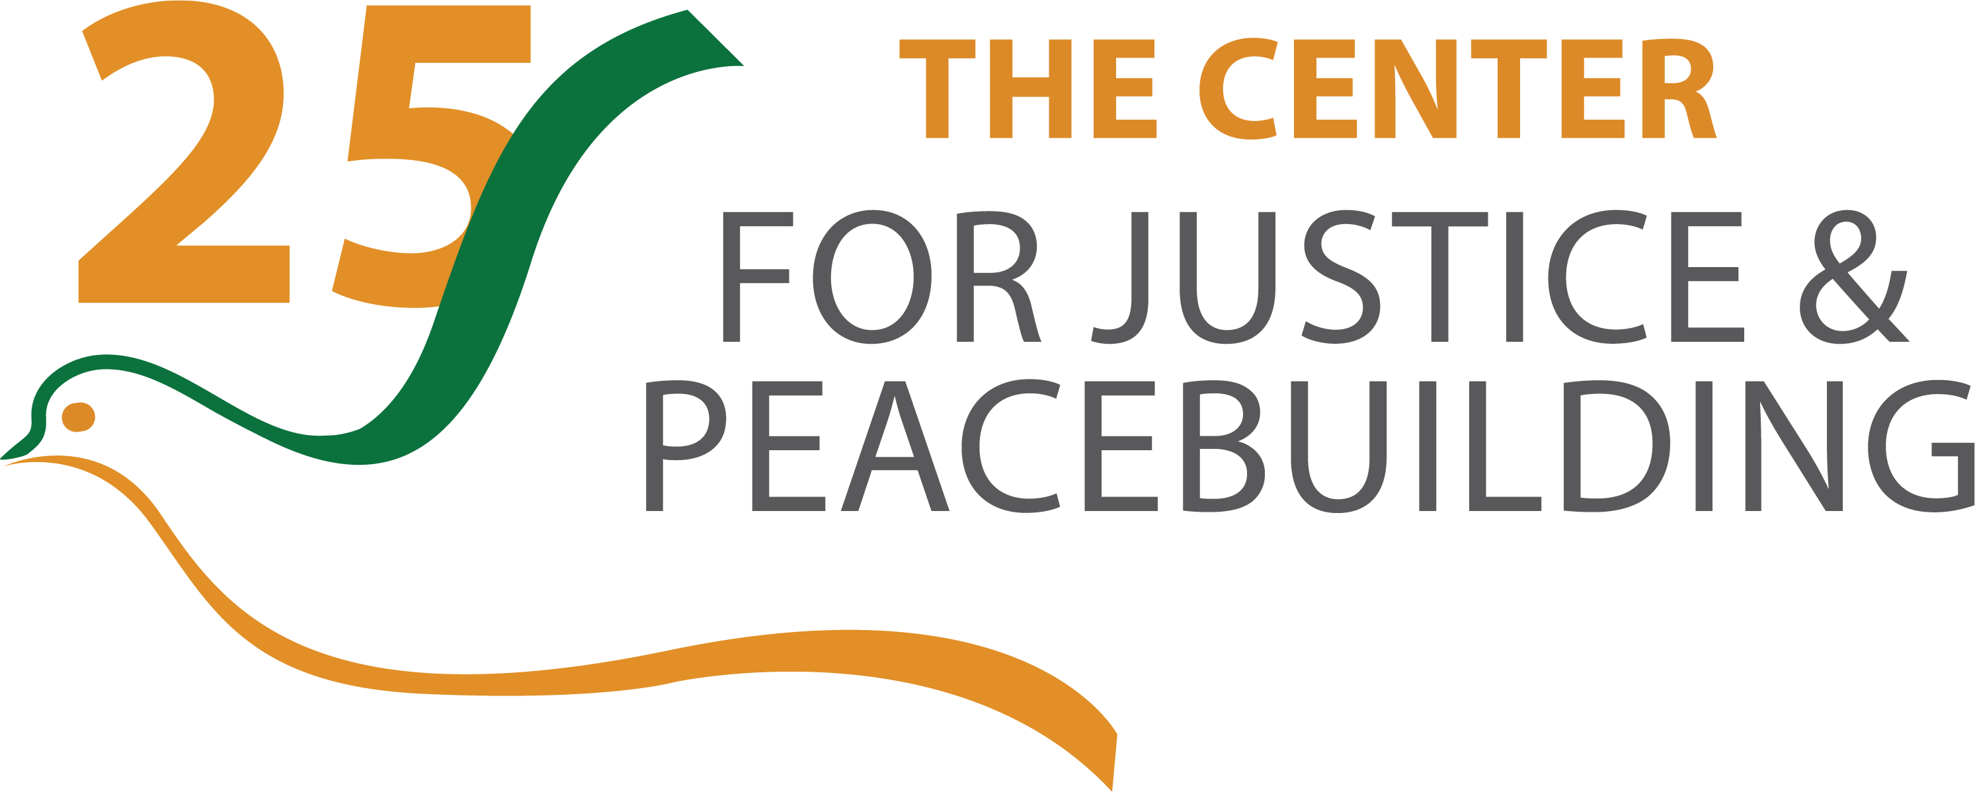 | Designing Processes for Conflict Transformation  PAX 685  DRAFT - Spring 2020  Online synchronously Fridays, 10 a.m. – 2:30 p.m. (Jan 22, 29, Feb 12, March 5, 26, April 16)  + asynchronous times via VoiceThread

Instructor’s Information:

Catherine Barnes, PhD
Catherine.barnes@emu.edu
Office hours: Individual and small group meetings happily arranged via zoom at mutually convenient times

Course Description:
Many of the systems in which we live and work are dysfunctional and mired in conflict. One strategy for transforming them is through deliberative dialogue processes that engage the whole system: whether community, organization or society. Such processes can enable us to respond creatively to our most complex challenges and move us toward more equitable, just and positive relationships and structures. Through this class, we will explore how complexity and identity theories, conflict analysis, and power assessment inform collaborative process design. We ask tough questions about what kind of processes are relevant for cultivating different phases of change and explore ethics underpinning the praxis of process design rooted in awareness of our ‘positionality’ in the system. We will learn about many process methodologies such as Appreciative Inquiry, Courageous Conversations, Emergent Strategies, Narrative Practice, Open Space, Polarity Management, Transformative Scenario Planning, World Café, and others. We will critically explore their underlying theories of change and theories of practice in ways that enable participants to become more creative and astute process designers. This class will be most appropriate for participants who already have some familiarity working with groups and is ideal for those with some facilitation practice experience.

Course Goals and Objectives:

- Drawing on context assessment and conflict analysis frameworks, learn how to conduct exploratory conversations that elicit perspectives, interests, needs, issues and hopes from key stakeholders. Use this insight to help frame an inclusive process with a clear purpose and to design an appropriate process to support the group through a change process.
- Gain familiarity with a range of process methods and their appropriateness for unique situations. Understand when and why to adapt them or to ‘mix and match’ methods.
- Understand the applications of theories of change and theories of practice to process design and to underpin more skillful and responsive action, supporting development as reflective practitioners.
- Engage with critical issues and dilemmas in process design for conflict transformation, learning from innovation and identifying ongoing critical edge challenges to inform praxis.
- Through an intersectional lens, develop an appreciation of the need to explore one’s own positionality in relation to the context and the group.
- Explore and articulate one’s own guiding values, principles, and ethics for engaging in group processes for conflict transformation.
Required Texts and Other Resources:

Participants are not required to purchase books for this class, as all readings will be available on the class moodle site from publications in the public domain or e-books available through EMU’s Hartzler Library.

Required Assignments:

This class is available for professional education / training for those who do not wish to take the class for graduate credit. If so, the expectations for class participation and engaging in the class forum remain the same as for those taking it for graduate credit.

Class participation  Everyone, including professional development | 10 points | Active participation in each of the 6 synchronous class sessions
Asynchronous participation  Everyone, including professional development | 15 points | Contributions to the online forums through responses to instructor and participants’ questions and comments, drawing on class readings, lived experience and other relevant sources.
Reflection paper  3-credit only | 25 points | Reflecting back on a personal experience in a group process, critically assess the process drawing on literature and concepts explored in class to identify insights and learning points for process design and facilitation (2,000-2,500 words; 6-8 pages)
Cumulative project  (choose 1 option)  3-credit and 2-credit students | 50 points | These projects will be ‘presented’ asynchronously as a virtual conference at the end of the semester.  - Option A: Process design for conflict transformation – (recommended for those engaged in an actual community / group / organizational context). Using the provided Guidance Note template, conduct a real assessment process, articulate framing purpose and guiding questions, outline possible phases and relevant process methods. - Prepare concept note (8-10 pages) and 10 min online presentation.  - Option B: Critical issues assessment and strategy – selecting a critical challenge for justice and peacebuilding, explore the ways that deliberative dialogue processes may support transformation. Draw on scholarly and practitioner literature to explore how this challenge is addressed by others (and, as relevant, in your own experience) to discuss strategies, opportunities and risks. – Prepare research paper (8-10 pages) and 10 min presentation

These are brief descriptions of required graded assignments for the course. More details for each assignment can be found on the “Guidance Notes” that will be provided in class.

Schedule and Topics:
Please note that this class is structured in a condensed format. Each of the six session comprises two regular semester ‘weeks’ and the amount of reading and preparation for each session is planned accordingly, with the class ‘front loaded’ with two sessions in January. Participation in each synchronous class session is necessary to successfully complete the course.

Jan 22 | Transforming conflict through whole of system dialogue  - Creating our container  - About dialogic processes and the dialogue, deliberation, decision-making cycle  - Underlying principles for process design  - Conflict and conflict transformation from a complexity perspective: exploring how dialogic processes can help to transform complex adaptive systems over time.  - Uncovering mental models, underlying assumptions & the power of perspective taking through group processes  - Process Methodologies and principles: Emergent Strategies; Open Space Technology  - Case exploration: Greensboro Truth and Reconciliation Commission
Jan 29 | Getting started: exploratory conversations, creating foundations and co-design (+ when NOT to dialogue)  - Getting started: engaging others and embracing the spirit of inquiry.  - Mapping the system; understanding your 'positionality' within it  - Process design elements and choices  - Context assessment, conflict analysis and tracking deliberative dialogue process design along the 'progression of social conflict' model  - Power dynamics, justice, ownership  - When not to engage in dialogue -- and how to prepare for more just and equitable dialogue  - On developing ethical practice: values, dilemmas and principles  - Process Methodologies and principles: Narrative Practice, Part 1; Appreciative Inquiry  - Case exploration: dialogue processes for Palestinians and Israelis
Feb 12 | Dialogue: shifting and changing through engaging together  - What is dialogue and how can it enable transformative change processes?  - Creating the potential for a new kind of politics through transversal dialogue  - Design principles for fostering deep dialogue processes.  - Framing the process; spirit of invitation; crafting questions  - Creating the 'container' to hold the group and enable alchemy  - Storytelling, narrative practice and the emergence of co-sensing  - Understanding polarities and polarity management processes  - Process methodologies: Narrative Practice Part 2; Courageous Conversations; Public Conversations Project / Essential Partners; Polarity Management  - Case exploration: dialogue over abortion; transversal dialogue and the Northern Ireland Women’s Coalition
Mar 5 | Deliberation: doing our best thinking together  - “The thinking that created the situation won't be the thinking that changes it" - principles and methods for diverging before emerging and converging  - Methods for opening-up generative thinking and creativity  - Methods and practices for scaling-up  - Process methodologies: World Café; America Speaks  - Case exploration: public policy disputes
Mar 26 | Consensus building, collaborative decision-making  - Supporting people within and through the 'groan zone'  - Chartering the process: mandate, authority, decision rule  - Consensus building theory, methods  - Process methodologies: decision rules and gradients of agreement  - Case exploration: TBD
April 16 | Working with the past; imagining the future  - Recognizing interdependencies; transforming unilateralism; exploring the future together  - Methods for exploring the legacies of the past: acknowledging harms, exploring accountability, affirming gifts, recognizing patterns  - Process methodologies: Transformative Scenario Planning; Future Search  - Case explorations: South Africa Mont Fleur process; Mennonite Church USA

Grading Criteria and Other Policies:

Will be added to the final syllabus.

